1.

package p;

public class Linear {

public static double factorial(double d)

{

if(d<=1)

{

return 1;

}

else

{

return d\**factorial*(d-1);

}

}

public static void main(String[] args)

{

double d=5.0;

*factorial*(d);

System.***out***.println("factorial of "+d+" is "+*factorial*(d));

}

}

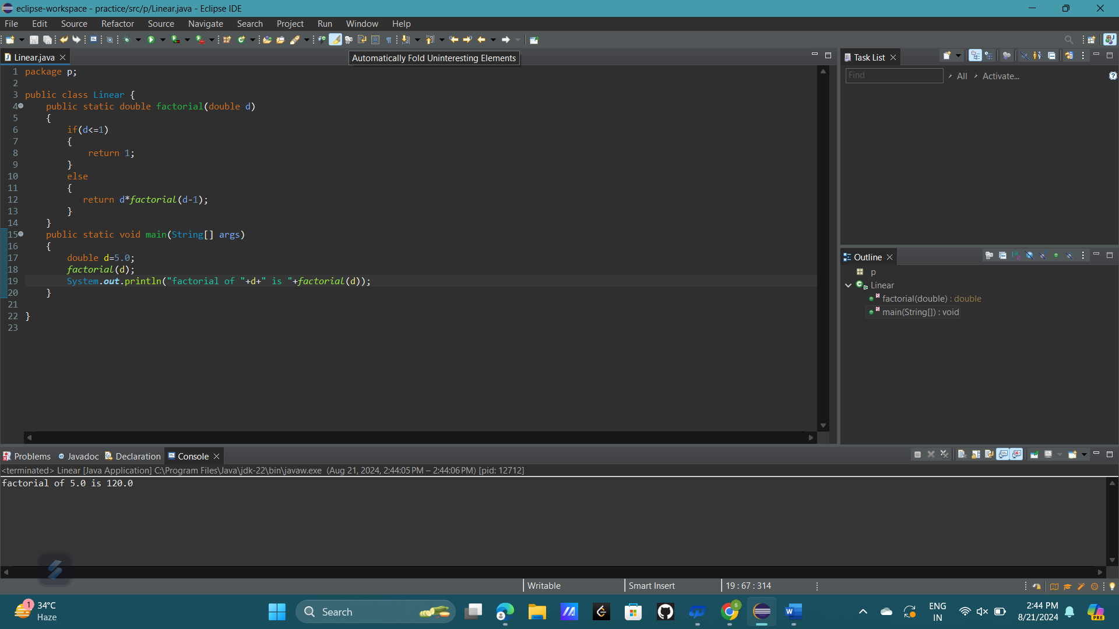

2.

package p;

public class NonLinear {

public static double fibonacci(double d) {

if (d < 2) {

return d;

} else {

return *fibonacci*(d - 1) + *fibonacci*(d - 2);

}

}

public static void main(String[] args) {

double d;

if (args.length > 0) {

d = Double.*parseDouble*(args[0]);

} else {

d = 5.0;

}

for (int i = 0; i <= d; i++) {

double result = *fibonacci*(i);

System.***out***.print(result+" ");

}

}

}

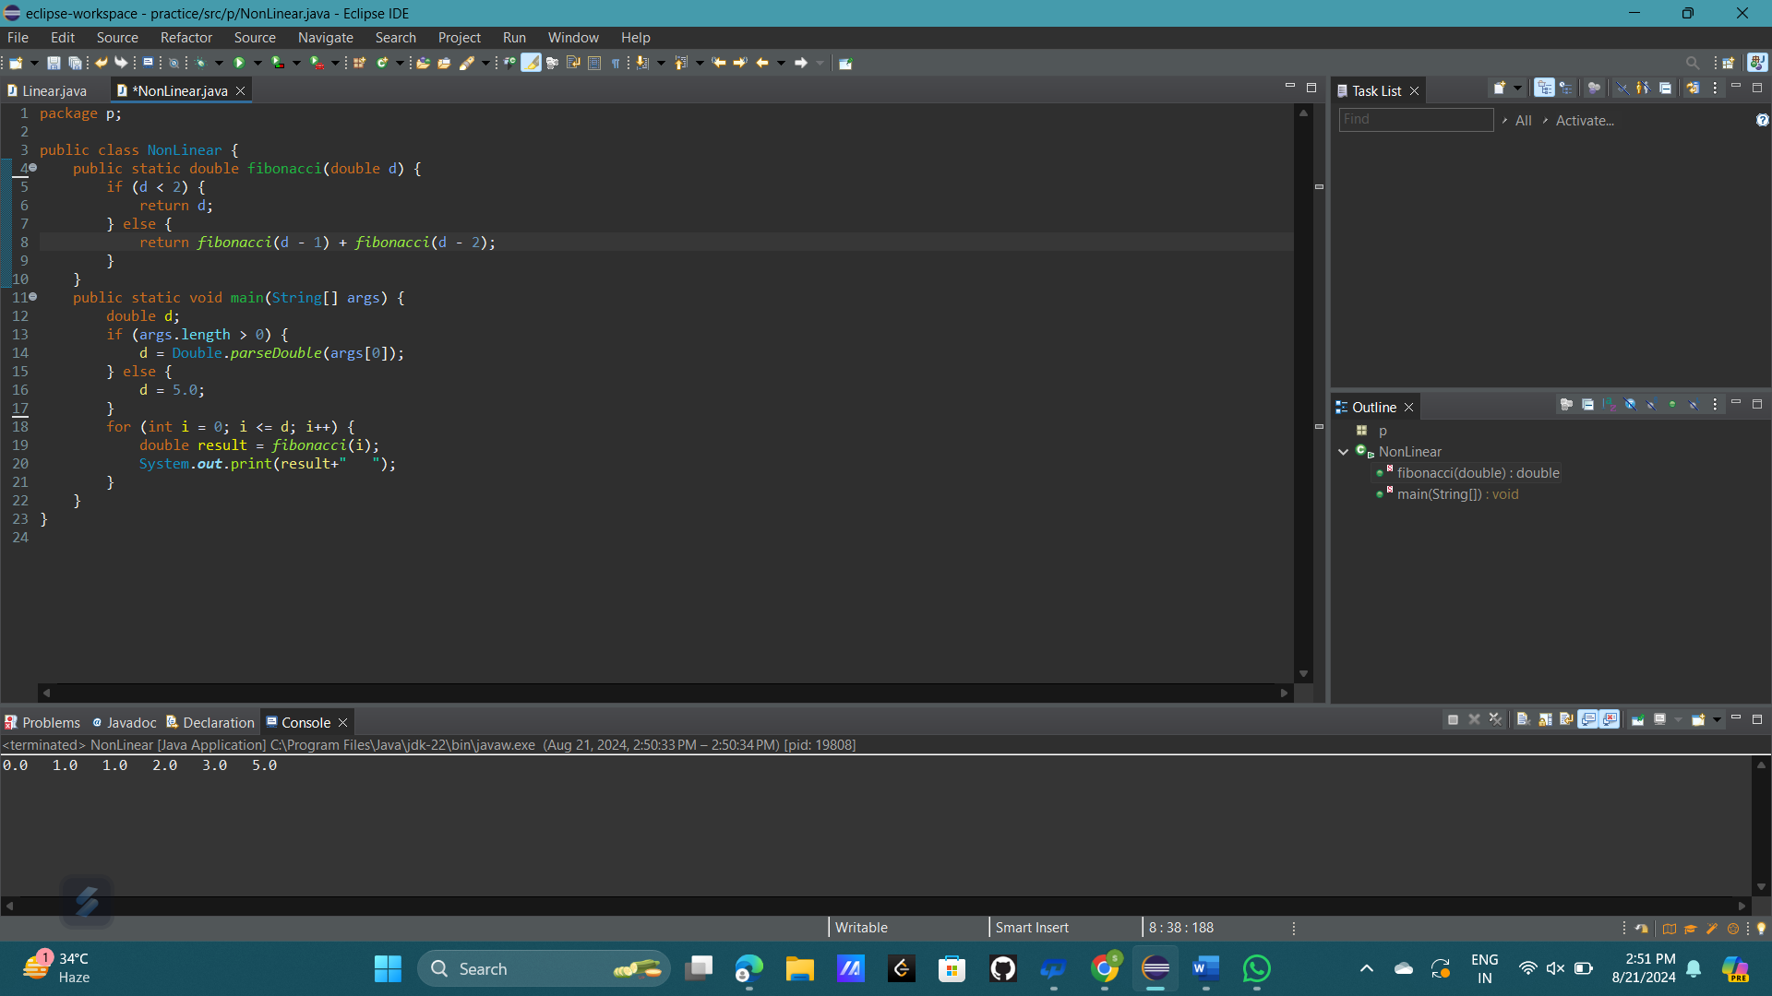

3.

package p;

public class Linear {

public static double factorial(double d)

{

if(d<=1)

{

return 1;

}

else

{

return d\**factorial*(d-1);

}

}

public static void main(String[] args)

{

double d=7;

*factorial*(d);

System.***out***.println("factorial of "+d+" is "+*factorial*(d));

}

}

